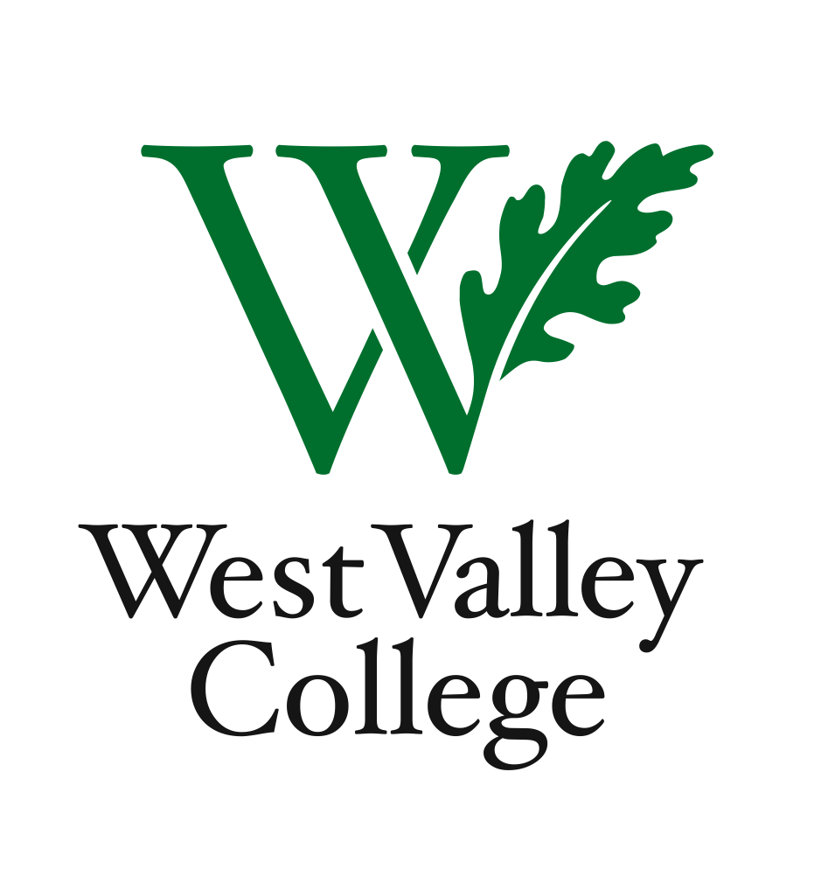
Student Learning Outcomes Committee
Meeting Summary Draft
October 25, 2012
2:45– 4:00 p.m.
Fox Center, room 211 (conference room)
Heidi Diamond, Committee Chair, Business | P | Peggy Mathieson, Academic Senate | P
Christopher Wright, Applied Arts and Sciences | P | Elizabeth Maciel, Administrative Services | A
Heidi Brueckner, Fine Arts | P | LeAnn McGinley, Assessment | P
Vacant, Language Arts | A | Inge Bond, Institutional Research | A
Rachel Sandoval, Library | A | Michelle Donohue-Mendoza, Student Services | A
Amy Vu, Math and Science | P | Sonia Espejo, Associated Students | P
Wendy Bowers-Gachesa, Physical Education | A | Stephanie Kashima, Dean of Instruction and Student Success | A
Vacant, Social Sciences | A | Tanya Hanton, Sr. Administrative Asst. and Meeting Recorder | P
Cheryl Miller, Curriculum Committee – Guest | P

I.Plan for assessing 107 unassessed courses this fall
  - Stephanie e-mailed a list of unassessed courses for the applicable departments to review. If assessments cannot be found, the chairs may need to contact the instructors who last taught the course to get whatever syllabi and grades they have.
- Integrated planning – connecting SLOs and Program Review
IB.6: “The institution assesses its evaluation mechanisms through a systematic review of their effectiveness in improving programs, student support services, and library and other learning and support services.”
  - Program Review Question #21 asks the following question: “Does the SLO process improve programs for student services, the library, instruction and student learning?” The answers to this question allow the reviewers to identify college-wide themes that show where goals are being met and where changes are needed. In addition to providing the division chairs with an overview of the departments, the themes offer College Council more concrete information as to where funds are needed to enhance student success.
  - Discussion of how SLOs fit into this integrated process followed.
III.Program Level Outcomes – template provided
  - The group reviewed the sample Program Level Outcome created by Heidi Diamond for an Administrative Management Certificate. The template ties individual Student Learning Outcomes to the Program Learning Outcome, and shows which Institutional Level Outcomes are supported. The template also contains a narrative response, lists the methods of assessment for the SLOs and indicates planned program changes and recommendations for college-wide improvements.
  - One question that arose was what to do if there are numerous courses that make up a PLO. It was decided that using capstone or required courses would be sufficient. The group also discussed the process of gathering the information needed for a PLO. One possible way might be to list all of the SLOs on one sheet, all of the PLOs on another sheet, and all of the ILOs on a third sheet; then, use the lists and the template to consolidate the information.
  - Heidi suggested that the representatives take the template back to their departments and ask the department chairs for their feedback.
IV. SLO committee/Curriculum committee collaboration to assist faculty with developing and revising student learning outcomes
  - Cheryl Miller, Chair of the Curriculum Committee, asked who faculty would consult regarding SLOs for new or revised courses. One goal of the SLO Committee is to have an SLO representative for each division who attends the SLO meetings and funnels information to and from the division. After the Department Chair approves the content of a new or revised course, the instructor can meet with the SLO representative who can answer questions and offer suggestions for the SLO assessment, insuring that the guidelines are followed. Ideally, the SLO Committee and Curriculum Committee representatives will confer and provide consistency and up-to-date information.
  - The assessment cycle is every three years for courses and every five years for programs.

V. Next meeting – November 8, 2012, 2:45 – 4:00 p.m., Fox 211
Summary prepared by Tanya Hanton

