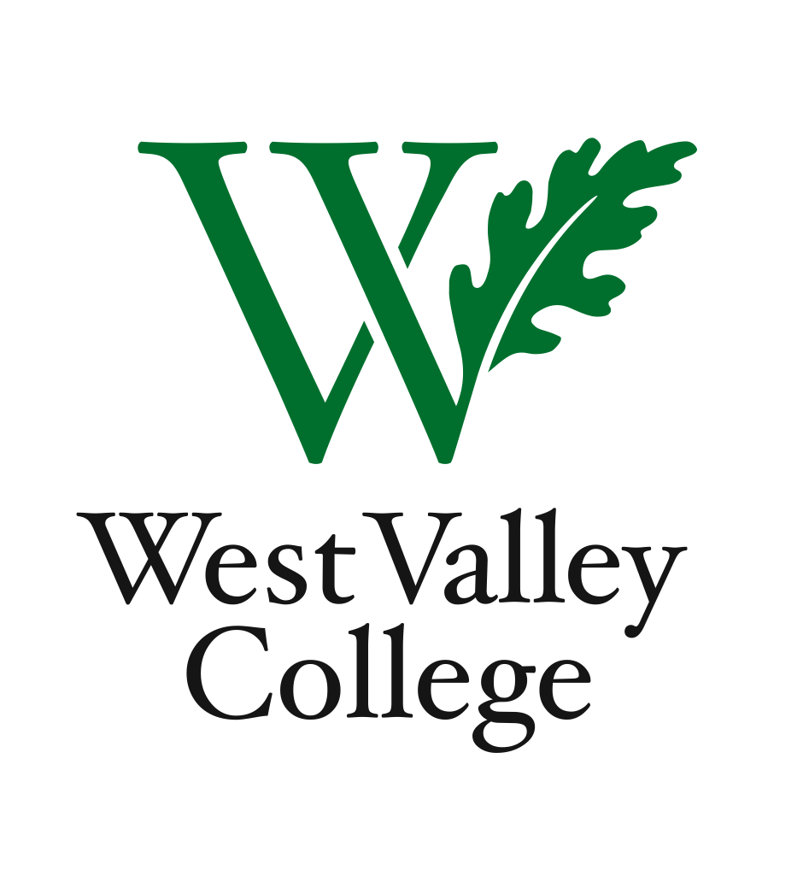
Student Learning Outcomes Committee
Agenda
February 23, 2012
2:45 – 4:00 p.m.
Fox Center, room 201

Heidi Diamond, Committee Chair, Business | Melvin Pritchard, Social Sciences
Christopher Wright, Applied Arts and Sciences | Michelle Donohue-Mendoza, Student Services
Heidi Brueckner, Fine Arts | Peggy Mathieson, Academic Senate
Vacant, Language Arts | LeAnn McGinley, Assessment
Rachel Sandoval, Library | Inge Bond, Institutional Research
Amy Vu, Math and Science | Elizabeth Maciel, Administrative Services
Wendy Bowers-Gachesa, Physical Education | German Diaz, ASO  Roxy Melnychuk, ASO  Robert Pelletier, Student

I. Proposal to link institutional learning outcomes (ILOs) with GE learning
outcomes. Establishing this linkage will provide clarity and organization for the
college community and our accrediting body (ACCJC).
II. Plan to complete the SLO assessment cycle and achieve 100% assessment rate
in 2012.
III. Discussion about interdisciplinary teaching and learning communities. How
might this work at our college, formally and informally?
IV. Student perspectives
V. Committee member reports
VI. Next meeting – Thursday, March 8, Fox Center, room 201, 2:45 – 4:00 p.m.
Future agenda item: Assessing Program Level Outcomes

