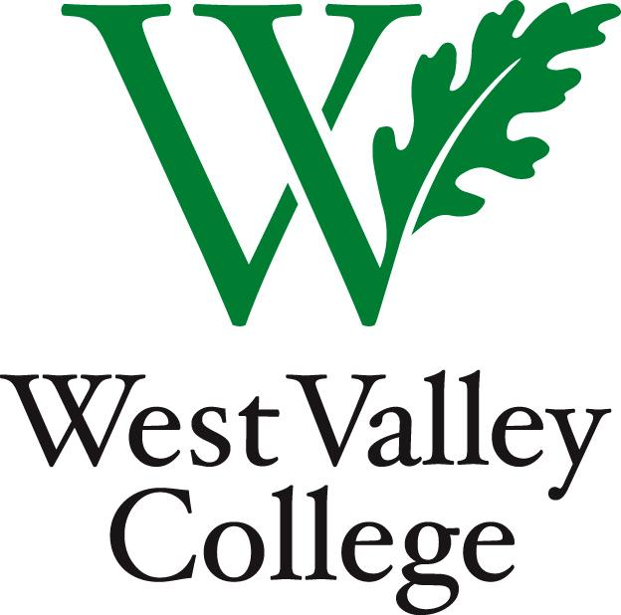

Program Review
2015 – 2016

Instructional self-study

Program Review Self-Study

The Self-Study section of this program review must be submitted by Friday, November 4, 2016.

You will find General Instructions for completing this program review as well as answers to some Frequently Asked Questions under the General Information and Contacts drop down of the Program Review tab at SLAPEC’s home page.

General

- What is the name of your program?

- Who is the primary contact person for this Program Review?

- Please list the names of others who will be collaborating on this program review:

- How does the program contribute to the fulfillment of the College’s mission? (Click here for the College’s mission statement)

- Describe any external influences that impact the program (Federal or State regulation, advisory boards, etc.).

Closing the Loop
In answering the following questions, please refer to the program’s most recent Program Review submissions. You may find these by clicking on the hyperlinks corresponding to the following academic years: 2013-2014 and 2014-2015. Program reviews for other years have been archived under Documents at the old Program Review committee home page.

- What were the program’s goals and objectives from its 2013-2014 and 2014-2015 program reviews? Please discuss how your program was successful in meeting its goals and objectives and any challenges faced by the program in meeting its goals and objectives.

- Was the program allocated any additional resources to help it meet its goals and objectives and influence student success? If the program was allocated additional resources, how did they help the program meet its goals and objectives? Alternatively, if the program requested resources that were not allocated, what was the impact on the program?

- What are the program’s proposed goals and objectives for the next 3 years? How do they align with the College’s 2020 goals and objectives? (See the Educational and Facilities Master Plan p. 12) What resources will help the program achieve these goals? What do you think you need today to help you meet your goals and objectives for the next three years? (Please include the details in the department’s Budget Resource Survey narrative portion of Program Review.)

CTE Labor Market
- Is your program a CTE? If you are unsure, then please visit the Associate Degree, Certificate & Selected Transfer Programs page for a list of CTE programs. If the program is on this list and if “Certificate” is indicated for it, then please answer “Yes” to this question and proceed to the next question. If “Certificate” is not indicated for this program, then please answer “No” for this question and skip to Question 14.

- Describe how your program meets documented labor market demand. List the job titles for which you train students, the skills needed for those jobs and describe how your program addresses those skills.

- What is the program’s current Net Annual Labor Market Demand (total job openings in area minus total completers at other programs in area)? Please refer to your program’s EMSI data by visiting the Office of Institutional Research and Planning's home page under the CTE Related tab. If you have any questions, or want to know how to determine your program’s Net Annual Labor Market Demand, please contact the Dean of Career Education & Workforce Development, Brad Weisberg.

- Please discuss the program’s plan to strengthen its ability to meet labor market demand.

- Does your program provide skill building for students to obtain employment outside the job titles officially linked to the program? Please describe/explain.

Curriculum
- Are all of the program's course outlines of record up to date? (CTE course outlines need to be updated every two years, non-CTE course outlines need to be updated every five years)

- If any of the program's course outlines are not up to date, identify the plan of action for submitting updated course outlines by September 2017 (list by course):

- When was the last time that the program’s degrees/certificates were updated? If the program’s degrees/certificates have not been updated recently, what is your program’s plan for updating them? (As per ACCJC guidelines, CTE programs need to be updated every two years, non-CTE course outlines need to be updated every five years).

- How many annual completers does the program have for each of its degrees/certificates? The data for the number of annual completers in your program is available in Canvas – Program Review – Data module in the spreadsheet: Five_year_awards_data.

Enrollment and Efficiency
Please refer to your program’s Annual Plan to inform your answers for the following questions. You may also view the data for this program's enrollment and efficiency in Canvas – Program Review – Data module in the spreadsheet: Course_offerings_and_enrollment_patterns.

- In comparing your program's enrollment trend to the College’s please comment on any differences between the trends:

- What was your program's efficiency goal for 2015-2016?

- In comparing your program's planned efficiency to its actual efficiency, please analyze and explain any differences.

- If your program is not meeting its planned efficiency goal, what program level practices will be created or modified to meet the goal during the next program review cycle?

Learning Outcomes
Please check the SLO/PLO Assessment Schedule for the program by visiting SLAPEC’s home page under "Master Schedule". The Master schedule includes submissions as of 7/15/16. Spring 2016 submissions are due October 30, 2016.

- Are there any Learning Outcome assessment results (Program Learning Outcomes (PLOs) and/or Student Learning Outcomes (SLOS)) submissions that have been scheduled that were not submitted? If so, please tell us how you will address these submissions.

- Beyond letter grades, how does your program define student success at the course and program level?

- How have the program’s assessments and discussions produced a positive impact for student success? Please share your success stories.

- Based on the assessment results and your department’s discussions, please explain why the program thinks students are, or are not, achieving the outcomes. What changes has the program made or is it planning to make to improve student success? (Some areas for consideration are Curriculum, Pedagogy, Technology, Learning Environment)

- What institutional changes need to be made to help the program improve student success? (Some areas for consideration are Technology, Facilities, Professional Development, Support Services, etc.)

Student Equity and Institutional Benchmarking (Instructional/Curriculum)

This year we are continuing the process of setting institutional benchmarks to narrow the achievement gap, and, as a College community, we will continue the conversation of how to improve student equity College-wide. The goal of the student equity questions is to identify any significant differences in student achievement so we can explore ways to address them. In order to assist you, the Student Success Team has identified research based effective strategies as options from which to choose. You may also select other strategies. The menu of strategies identified by the Student Success Work Team can be found by navigating to: Student Success Strategies.

- The course completion and course success rates for your program over the last five years are available broken down by different demographic categories in Canvas – Program Review – Data module in the spreadsheet: Five_year_course_data. What do you notice in this data?

- How successful was your program in increasing the achievement rates in course completion and course success for Latino and African American students between the 2014/15 and 2015/16 academic years? If successful, please explain to what you owe your success. What do you plan to do to improve or continue to improve the achievement rates?

- The data provided in Canvas – Program Review – Data module in the spreadsheet: Five_year_course_data includes the overall totals/percentages for the 2015/16 year. Between the 2015/16 and 2016/17 academic years the college goal is to increase by one percentage point in course completion and course success rates. Use the provided data to identify your new goal for next year. What actions is your program planning to take to help achieve this benchmark? How can your program partner with student support services such as the Office of Student Equity, the Student Success Team, Tutorial Services, etc. to achieve this goal?

Conclusions

- Please describe any notable accomplishments since the last program review.

- Is there anything else you would like to report that was not included in the answers to the previous questions?

- What general conclusion(s) do you draw about your program's strengths and challenges at this time?

- Please enter the date on which you submitted this program review Self-Study (Please be sure to press submit after completing this survey):

Now that you have reflected back on the previous academic year and set goals for the next year, please proceed to fill out the Budget and Resources Allocation Survey narrative. This narrative looks ahead to 2017/18 and future years. It can also alert the Budget and Resource Allocation Committee to needs that can be met during the current academic year if resources are available.

Program Review

budget and resources allocation survey
looking ahead to 2017-2018

Budget and Resource Allocation Request

The Budget and Resource Allocation narrative section of the program review must be submitted together with the Program Review Self-Study by Friday, November 4, 2016.
Your program will be asked next semester to provide to the Budget and Resource Advisory Council (BRAC) a complete organizational budget for the next fiscal year; information supplied in this Program Review narrative is used to support substantive changes to budgets, especially as relates to new or significantly increased expenditures, equipment, software & information systems, and staffing. You may find some answers to your questions and other useful information at BRAC’s website. For definitions, examples, and other information pertaining to this Budget and Resource Narrative Self-Study, you may download the current BRAC “Budget Development Handbook”, as well as other supporting documents, from the Documents folder of BRAC’s website. If you have questions regarding this Budget and Resources Self-Study, please contact the Budget and Resource Advisory Council (BRAC).

General

- What is the name of your program?

- Who is the primary contact person for this program review?

- Please list the names of others who will be collaborating on this program review:

- Examining your current fiscal year budget, has the funding been adequate to meet the needs of your program? If not, please explain.

- If you are requesting additional budget and/or resources for the 2017-18 year, explain how those resources will be used, especially to improve learning outcomes and program goals. Please provide specific examples and rationale.

Note: Please describe and explain below only those resources that represent a substantive change to your organization’s budget, especially as relates to new or significantly increased expenditures, equipment, software & information systems, and staffing.

Personnel

If your program requires personnel beyond staffing currently budgeted, enter your additional full-time and part-time personnel resource needs here. Any needs that require you to request faculty hiring prioritization must be included in this program review.

However, it is not the scope of the program review and annual budget allocation process to fund resources for additional full-time personnel. Requests for new permanent employee positions must be made to the President’s Cabinet and District’s Executive Management Team through coordination with your Division/Program Chair. Only resource requests for hourly employees will be considered and funded based on the information you provide in this program review.

- Personnel – Full-time Instructional
Please describe the specific position(s) and the number of positions only. (For example: We need two additional Mathematics instructors.)

- Personnel – Permanent Non-Instructional
Please describe the specific position(s) and the number of positions only. (For example: We need two additional laboratory aides or classified staff.)

- Personnel – Part-time Hourly
Please describe the specific position(s), the total number of hours for each position, and the hourly rate, if known. (For example: We need two additional part-time laboratory instructional aides to work for 40 hours per week per semester estimated at $15 per hour for an estimated total of $19200 per academic year)

Materials and Supplies
Please indicate only the resources being requested that are above the program’s base-level, currently budgeted recurring needs. Note that “Instructional” indicates the expenditure is for items used to support direct student instruction, i.e. – used by students in the classroom or lab. “Non-Instructional” are items not used by students.

- Materials and Supplies – Instructional

- Materials and Supplies – Non-Instructional

Other Operating Expenses and Services
Please indicate only the resources being requested that are above the program’s base-level, currently budgeted recurring needs.

- Other Operating Expenses and Services – Contracted Services

- Other Operating Expenses and Services – Dues

- Other Operating Expenses and Services – Memberships

- Other Operating Expenses and Services – Consulting Services

- Other Operating Expenses and Services – Repair / Maintenance

- Other Operating Expenses and Services –Travel and Conferences. Note that Faculty Travel and Conference funding is covered by ACE contract, which provides $200 per faculty member annually.

Equipment
Please indicate only the resources being requested that are above the program’s base-level recurring needs.

- Equipment – Computer and Technology (Computers of any type, tablets, printers, accessories).
Indicate whether the equipment is used for direct student instruction or for other office or administrative, non-instructional purposes.

- Computer Software
List both recurring software license fees and any new software purchase requests. Also indicate whether the software is used for direct student instruction or for other office or administrative, non-instructional purposes.

- Equipment – Other
Please indicate whether the equipment is used for direct student instruction or for other office or administrative, non-instructional purposes.

Other

Please indicate only the resources being requested that are above the program’s base-level recurring needs.

- Other – Other

- Please enter the date on which you submitted the Budget and Resource survey (be sure to click submit when you are done):

