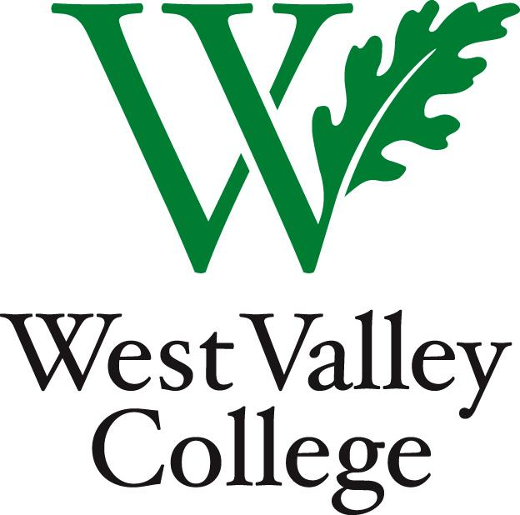

Program Review
2014 – 2015

Self-Study and Budget Surveys
Instructional Update Rubric

Program Name:
1st Reader:
2nd Reader:
Submission Date:
Review Date:

The Student Learning and Program Effectiveness Committee has reviewed the indicated Program Review and has determined that:

This program review meets or exceeds all institutional expectations and therefore recommends that it be forwarded to the Office of Instruction for approval.
This program review does not meet institutional expectations in one or more areas and thus requires changes and/or additional information.
Revisions to this program review must be submitted by (date):

If your program review does not meet institutional expectations, please read the reader(s)’s comments below and as they appear in this assessment and contact SLAPEC for more support. You will have to resubmit your program review by the due date indicated above.

Overall Comments:
(Required if a Program Review is Inadequate)
Summary of Program Review

Strengths:

Goals and Improvements:

Challenges faced:

Recommendations:

Supporting Documentation
Is Supporting documentation or revisions included? | Y | N
Reader: Please list the file names of the supporting documentation in this space, including revisions to survey questions.

General | A | B | C | D | NA
- Name of program
- Name of primary contact person
- List of Collaboration Team (Exemplary if submitter worked with others on the program review)
- Description of program’s contributions to the College’s mission.
- Explanation of external influences.
Notes/Comments:

CTE Labor Market  Note: In the actual survey administered, question 7 appears as question 6 and question 6 appears as question 7. | A | B | C | D | NA
- This is a CTE Course (A “Y” written in column “A” indicates a Yes response, while an “N” written in column “B” indicates a No response. If “Y”, skip to question 10. If “N”, then an answer to each question is required. | Y | N
- Meets labor market demand
- Compares similar programs in the area
- Analyzes evidence of effectiveness/Student completion or job attainment
Notes/Comments:

Closing the Loop | A | B | C | D | NA
- Explanation of progress in implementing proposed 2014-2015 actions and objectives
- Evaluation of impact of implemented actions and objectives
- Explanation of modifications or new goals/objectives/plans
Notes/Comments:

Curriculum and Articulation | A | B | C | D | NA
- Course outlines are up-to-date. | Y | N
- Describes out-of-date outlines and action plan for updating (Required explanation if “No” was indicated in the previous question.)
- Explains adequacy of course articulation agreements
Notes/Comments:

Learning Outcomes | A | B | C | D | NA
- Assessments are up-to-date. If “no”, must provide explanation. | Y | N
- Explanation of “no” answer
- Discussion of impact that outcome assessments have had on student success.
- Explanation of improvements based on assessment results.
- Describes institutional changes needed to improve student success.
Notes/Comments:

Student Equity | A | B | C | D | NA
- Discussion of differences in student equity within the program
- Program goals address differences in student equity.
- Strategy proposed to meet program goals to address student equity.
- Describes necessary institutional support needed to implement program’s plan to address student equity differences.
Notes/Comments:

Conclusions | A | B | C | D | NA
- Notable accomplishments
- Analyzes strengths and challenges
Notes/Comments:

Budget Survey  (These questions appear in the Budget Survey for this program) | A | B | C | D | NA
- Discussion of whether the current fiscal year’s budget has met the needs of the department.
- Explanation of how additional resources will be used, if requested.
Notes/Comments:

Revision # | Revision Date: | Document Name | Questions Revised

