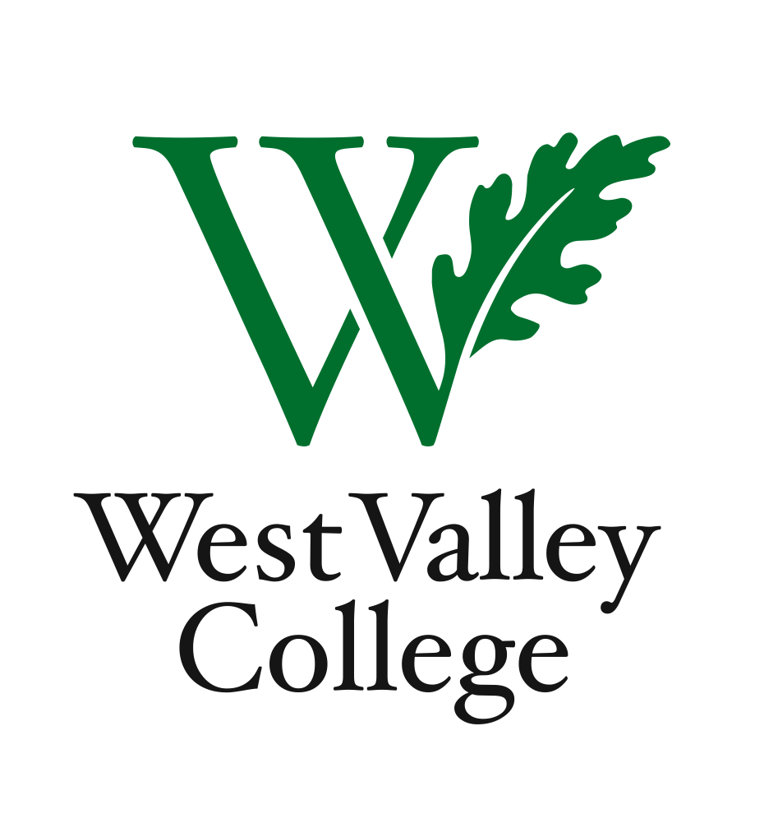
Student Learning Outcomes Committee
Agenda
October 25, 2012
2:45– 4:00 p.m.
Fox Center, room 211 (conference room)
Heidi Diamond, Committee Chair, Business | Vacant, Social Sciences
Christopher Wright, Applied Arts and Sciences | Michelle Donohue-Mendoza, Student Services
Heidi Brueckner, Fine Arts | Peggy Mathieson, Academic Senate
Vacant, Language Arts | LeAnn McGinley, Assessment
Rachel Sandoval, Library | Inge Bond, Institutional Research
Amy Vu, Math and Science | Elizabeth Maciel, Admin. Services
Wendy Bowers-Gachesa, Physical Education | Sonia Espejo, WVC student
Stephanie Kashima, Dean of Instruction and Student Success

I. Plan for cleaning up active/inactive course lists
II. Integrated planning – connecting SLOs and Program Review
IB.6: “The institution assesses its evaluation mechanisms through a systematic review of their effectiveness in improving instructional programs, student support services, and library and other learning support services.”
III. Program Level Outcomes: narratives, department visits
IV. Committee member reports
V. Next meeting – November 8, 2012, 2:45 – 4:00 p.m., Fox 211

