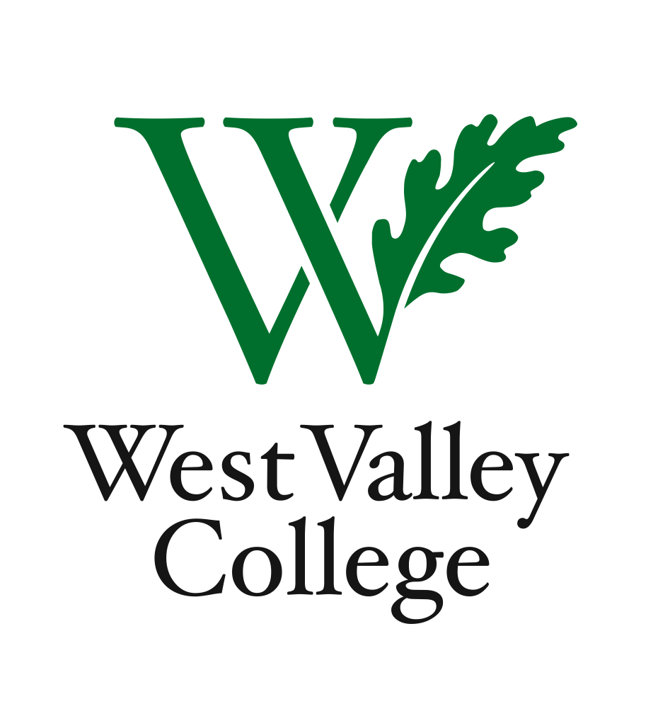
Student Learning Outcomes Committee
Agenda
April 12, 2012
2:45 – 4:00 p.m.
Fox Center, room 201
Heidi Diamond, Committee Chair, Business | Melvin Pritchard, Social Sciences
Christopher Wright, Applied Arts and Sciences | Michelle Donohue-Mendoza, Student Services
Heidi Brueckner, Fine Arts | Peggy Mathieson, Academic Senate
Vacant, Language Arts | LeAnn McGinley, Assessment
Rachel Sandoval, Library | Inge Bond, Institutional Research
Amy Vu, Math and Science | Elizabeth Maciel, Administrative Services
Wendy Bowers-Gachesa, Physical Education | German Diaz, ASO  Roxy Melnychuk, ASO  Sonia Espejo, WVC student

I. Updates from recent Research Professionals Group Conference
II. Release of ACCJC reporting guidelines for meeting SLO proficiency by the fall 2012 deadline
III. Program Level Outcomes
IV. Student perspectives
V. Committee member reports

