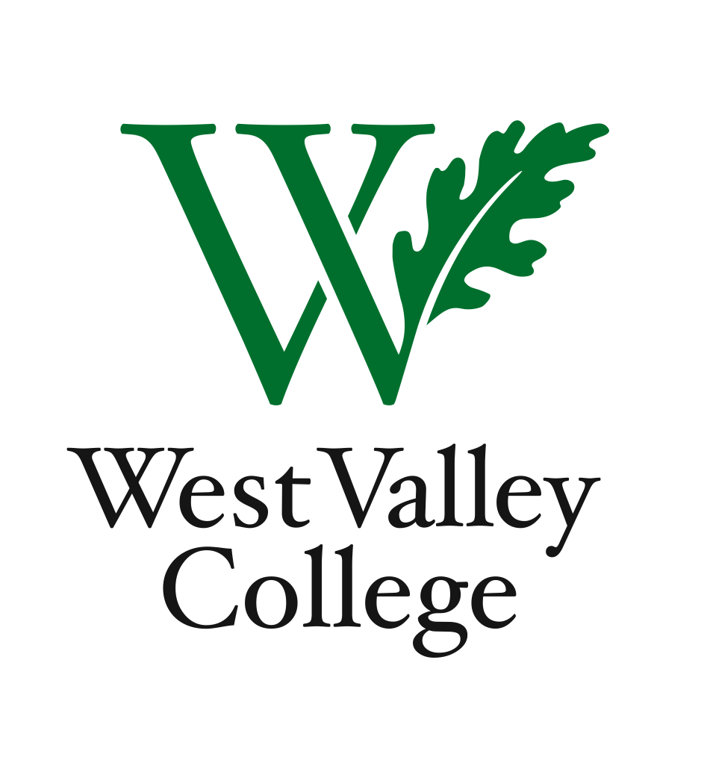
Student Learning Outcomes Committee
Agenda
September 13, 2012
2:45 – 4:00 p.m.
Fox Center, room 211 (conference room)
Heidi Diamond, Committee Chair, Business | Melvin Pritchard, Social Sciences
Christopher Wright, Applied Arts and Sciences | Michelle Donohue-Mendoza, Student Services
Heidi Brueckner, Fine Arts | Peggy Mathieson, Academic Senate
Vacant, Language Arts | LeAnn McGinley, Assessment
Rachel Sandoval, Library | Inge Bond, Institutional Research
Amy Vu, Math and Science | Elizabeth Maciel, Administrative Services
Wendy Bowers-Gachesa, Physical Education | Sonia Espejo, WVC student

I. Status of SLO assessments
II. Completing PLO assessments
III. Plan to complete all assessments by ACCJC deadline – Fall 2012
IV. Student perspectives
V. Committee member reports
VI. Next meeting – September 27, 2:45 – 4:00 p.m., Fox 211

