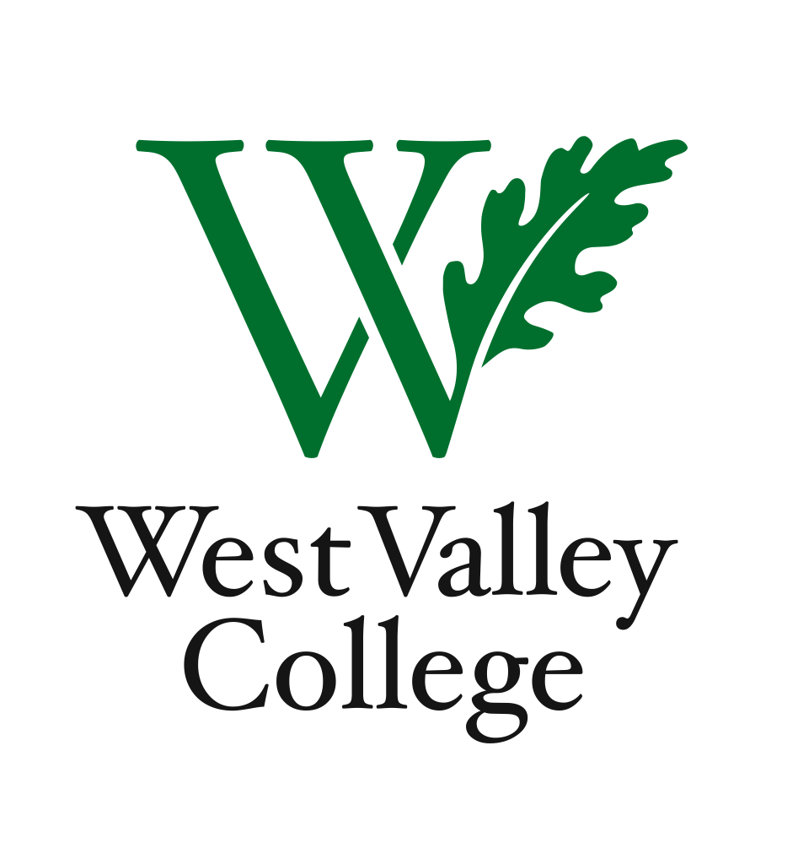
Student Learning Outcome Committee
Agenda
September 8, 2011
2:45 – 4:00 p.m.
Fox Center, room 201
Heidi Diamond, Committee Chair, Business
Christopher Wright, Applied Arts and Sciences
Heidi Brueckner, Fine Arts
Vacant, Language Arts
Rachel Sandoval, Library
Amy Vu, Math
Wendy Bowers-Gachesa, Physical Education
Vacant, Social Science
Michelle Donohue-Mendoza, Student Services
Peggy Mathieson, Academic Senate
LeAnn McGinley, Assessment
Inge Bond, Institutional Research
Vacant, Student

I. Welcome
II. Status of SLO assessments
III. Including SLOs of record in course syllabi
IV. SLOs and Integrated Planning
V. Program Level Outcomes
VI. Next meeting – Thursday, September 22, Fox Center, room 201, 2:45 – 4:00 p.m.

